Content and Collaborative based Sinhala Book Recommendation System

P.N.C. Perera
2024




Content and Collaborative based Sinhala Book Recommendation System

A Thesis Submitted for the Degree of Master of
Computer Science

P. N. C. Perera

University of Colombo School of Computing

2023

Declaration

I would like to dedicate this thesis to my beloved wife, parents and all readers and authors in Sri Lanka

ACKNOWLEDGEMENTS

Completing the Master degree program while working in a stressful environment and fulfilling the duties of a father was a challenging task. It was a great life experience to manage all the tasks without delay. I would like to take this opportunity to all the people behind me and helped me to complete the master’s degree program.

First of all, I would like to express my heartfelt gratitude to my supervisor Prof. M.G.N.A.S. Fernando providing guidance, comments, feedback, and vital support throughout the entire research in order to make it a success.

Next, I would like to express my sincere gratitude to famous Authors Dileepa Jayakody, Shamel Jayakody and Nethindu Warapitiya for the help and support provided by evaluating the system and sharing their expertise knowledge with feedback to enhance the application.

Furthermore, I would like to thank all the book readers in Facebook groups who helped me to collect the dataset by filling a google form. Without the dataset I would not be able to complete the research as the model was implemented based on the dataset which is not available in online dataset providers like Kaggle.

Finaly, I would like to thank my beloved wife, fellow colleagues, and all the lecturers at the University of Colombo, School of Computing for their help and support throughout the research.

ABSTRACT

The saying "Reading makes a man perfect" tells us how important it is to gain knowledge by reading different things like books, articles on the internet, newspapers, magazines, or even simple pieces of paper. This article talks about how reading a lot can have a big impact on people. It says that people who read regularly usually have a better understanding of life, make smarter choices, and handle difficult situations better.

The traditional way of picking books, like choosing randomly or going by recommendations, can be hard, especially as libraries have more and more books. The COVID-19 pandemic and distance can make it even harder for people to find the books they want.

This situation shows that there is a need for a better way for people to borrow books from the library. While many online platforms use systems that suggest products, these usually focus on making more sales and not necessarily on what the user really likes.

This article talks about the lack of a system that suggests Sinhala books and suggests a new idea. The proposed solution combines both content and collaboration methods to create a hybrid model for recommending Sinhala books. This system aims to help online users find interesting and relevant books without wasting too much time and money. It not only benefits readers but also gives useful information to authors, helping them understand what readers like and adjust their writing to match popular interests. This recommendation system has the potential to change the way Sinhala books are discovered and chosen, making it a useful tool for both readers and authors in the digital age.

Keywords: Sinhala Books, Collaborative filtering, Content based filtering, Hybrid model, Recommendation system
TABLE OF CONTENTS

ACKNOWLEDGMENT………………………………………………………………………..…….iii
ABSTRACT…………………………………………………………….………………………..……iv
TABLE OF CONTENT………………………………………………………………….…….….…...v
LIST OF FIGURES…………………………………………………………………….………..….....vi
LIST OF TABLES………………………………………………………………………..……..….....vii
LIST OF ABBREAVIATIONS………………………………………………………………....…....viii

LIST OF FIGURES

LIST OF TABLES
LIST OF ABBREAVIATIONS
Term | Definition
AI | Artificial Intelligence
ANN | Artificial Nural Network
CBF | Content Based Filter
CF | Collaborative Filter
CTR | Click Through Rate
GUI | Graphical User Interface
IDE | Integrated Development Environment
KNN | K Nearest Neighbors
MAE | Mean Absolute Error
MS | Microsoft
NLP | Natural Language Processing
OS | Operating System
RMSE | Root Mean Square Error
RS | Recommender System
SDLC | Software Development Life Cycle
SVD | Singular Value Decomposition
UI/UX | User Interface and User Experience

CHAPTER 1

INTRODUCTION

Chapter Overview
This chapter provides a foreword for the project in terms of background study, problem domain, the main aim, objectives, scope and activities that will be carried out towards the completion of the research. Finally, the chapter concludes with an overview on how the other chapters of the document fit into the project context.

Background
From our childhood, everyone has heard that “Reading makes a man perfect”. People acquire the knowledge by reading a variety of materials. These materials could be a book, an internet article, a newspaper, a magazine, or even a piece of paper, and the gain knowledge by reading these materials is intense. People who read a lot tend to know more about life and are smarter when making decisions and handling difficult situations. (Marappan, 2022) It may not be possible for the reader to “know it all,” but a lot of reading brings man close to perfection. Most of them like to read books as a hobby because it imagines readers' own movie in their mind rather than watching a movie directed by someone.

In today’s world, time has more value and the researchers have no much time to spend on searching for the right articles according to their research domain. (Murali et al., 2019)

Book readers usually select books by reading some random pages or asking someone to recommended any book. When reading that book, if he finds that the book is not interesting, he will not read any book after that. therefore, it is better to suggest books that he is interested in. With the increase in library collections, it is diﬃcult for readers to quickly ﬁnd the books they want. It is also diﬃcult for readers to ﬁnd Sinhala books of interest in a short period of time in the face of various bibliographies. Therefore, the user experience of the traditional library borrowing method is poor.(Dhanda and Verma, 2016) Due to the Covid-19 pandemic situation and the geographical barriers also it becomes a tremendous challenge for readers (Sarma et al., 2021) to find a relevant book as they do not like to go out and spend time searching books of their preference. Even the pandemic period is over it is better to be prepared to face such situation in future.

Motivation
When we navigate through social media like Facebook there are so many groups available for almost everything. If you are living in an area, there is a group for that area, if you have an aqua car, there is a group created for aqua car owners. The benefits of such group are you can learn many things and if you have any question you can ask from the group and get it clarified. For Sinhala book readers also, there are so many groups available in the Facebook. You can share what your thought on a specific book or you can see what are latest books released through the groups if you follow those groups. One thing I have noticed is many people asking I have read this particular book; can anyone suggest similar type of books. And some asking what are the books related to Sri Lankan history or related to world war. Some other have asked whether the book is good to read by uploading an image of the book. When considering these three scenarios I thought like it is better to have a system that displays what other users’ thoughts about a book and how much of rate could be given to the book and what are other similar books. It gives the motivation to initiate kind of such system for Sinhala book readers.
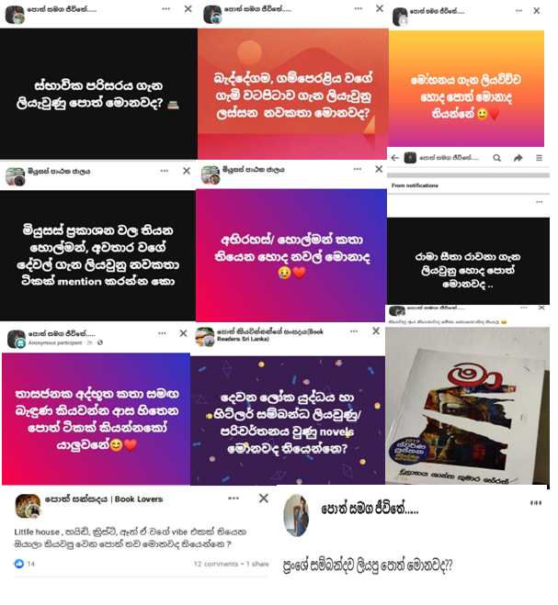

Figure 1: Questions Users ask from groups

Statement of the problem
Most organizations like Amazon, Ebay have implemented their recommendation system when users buy products online. But almost all the websites are not developed for the buyer's interest; the organizations force add-on sales to buyers by recommending unnecessary and irrelevant products (Sarma et al., 2021) If book recommendation point of view for an instance, if a user has read a book named ‘Madol Duwa’, he would like to read similar books and there is no Sinhala book recommendation system to address this problem. Additionally, some members of readers groups on Facebook have problems like, is this book good or I have read this book and are there any similar kind of books like the mentioned book?
Many personal book recommendation systems have emerged to conduct eﬀective search based on user rating and interest.
This paper proposed an effective Sinhala book recommendation system for online users that rated a book list using the content and collaboration (hybrid) method. The solution could be used by all Sinhala book readers to find interesting or suitable books without wasting time or money. Authors also could use the system to have an idea of what kind of books readers rate and are interested more and write books accordingly.

Research Aim and Objective

Aim
The main aim of the research is to analyze, design, implement and evaluate an accurate recommendation system related to Sinhala books using content and collaboration algorithms with attractive user-friendly interface which display the searched book details along with already given reviews and suggesting a list of recommended books. The main aim can be further divided to three sub aims as;

- Input Data will be a dataset collected from readers.
- Preprocess collected data set by removing null values and unwanted data then apply the content and collaborative algorithm respectively
- Combine Content based list and collaborate based list and finally output data will be displayed in the system.

Objective
The final outcome of this project is helping Sinhala book readers to find correct and recommend books based on their preferences using content and collaboration algorithm. There is no exact formula for determining how much data would be enough for a recommendation system. Even though capturing many data sets, ends up with manageable data sets after preprocessing and removing null values from the collection list as most online dataset contains parsed data.

The main goal of this research will be achieved by targeting the following objectives.

- To Collect selected Sinhala book details like title, author, publisher, description, image url and keywords. Online book stores will be used for collecting the details of books.
- To produce a data set containing user details, selected Sinhala books and rates given by users for those books.
- To implement web application along with login and registration features.
- To recommend ten books based on specific field of interest using Content and Collaborative (Hybrid) methodology.
- To determine the categories preferred by readers so that it motivates authors to write books as per the user’s preference.
- To Increase the number of book readers by recommending books according to their preferences.

Scope
The scope of the project can be defined as bellow.
- Sharing a google form containing selected books along with authors and collecting user rates and reviews for those books based on previous readers experience.
- Applying sentimental analysis for the reviews collected from above and assigning a new rate.
- Provide facilities for readers to login or register to the system with their email id which is unique.
- Provide facilities for readers to search a specific book in the repository and it will display the details such as author, publisher and image along with the reviews and rates given by users.
- Additionally, the system will display a list of recommended Sinhala books based on users’ rates and reviews of specific interested field. Content based and Collaborative based (Hybrid) approach will be taken place in order to recommend books.
- Only Sinhala books are recommended and it is based on users’ rates and reviews as well as keywords provided for selected books

We can use library to collect book details, but we will not be able to collect user reviews and rates for selected books. I am using online book store to collect book details but I preferred to get user reviews and rates from users themselves so that they are aware that they have provided the information for the application rather than just coping from the online without their awareness. 4200 records have been collected so far and they will be used for the research as the data set is considerable amount of data for a machine learning application.

Resource Requirement
In order to implement and execute the application, following hardware and software requirements should be satisfied.

Hardware Requirement
- A Laptop or desktop with core i3 or above processor
- At least 4GB Ram
- At least 30GB

Software Requirement
- Python latest version – 3.12.0
- VS code as IDE for implementation and execute the application
- MS Excel and Notepad ++ for viewing and manipulating data
- Stable internet connection for downloading relevant libraries.
- GitHub for storing images and implemented code

Structure of the Thesis
The outline of all the chapters are as follows.

Chapter 02: Literature Survey
This chapter will discuss about the review, conducted on the proposed project. It will extensively describe on the stakeholders, the problem, existing solutions, methodologies, and approaches along with their benefits and limitations.

Chapter 03: Methodology
This chapter will discuss about the methodology to be used to implement the solution. The stakeholders, main technology, libraries, prioritized items, how the collected data is analyzed and the how the architecture of the system will be organized will be in detailed discussed. Furthermore, why the selected technology is more suitable than other existing technologies will be clarified.

Chapter 04: Implementation
This chapter covers the implementation stage of the project. Algorithms used and challenges faced and how they are resolved will be discussed in this phrase. Screen shots and code segments for some selected functionalities are also provided to facilitate easier understanding and manipulating over the project implementation.

Chapter 05: Evaluation and Results
The evaluation chapter provides how the results are evaluated based on the feedback collected from Domain experts in this projects Authors. The project will be shown to them and get the feedback for the evaluation. Other than that validation methods will be used to further evaluate the accuracy of the system.

Chapter 06: Conclusion and Future work
The objectives that were able to be successfully achieved will be discussed in conclusion chapter. The challengers and the limitation of implemented system will be highlighted in order for someone to enhance the system.

Chapter Summary
The chapter began with explanation on background and problem domain of the system. Although many applications have been developed for book recommending systems, most of them are related to English books. Proper applications that satisfy all the requirements with user satisfaction were limited. The main approach is to make an application that help all Sinhala book readers to recommend Sinhala books based on their preference. A goal followed by objectives was defined to make the effort to be success.

